Phytohormone
Plants produce signaling molecules that have profound effect on growth and development. These molecules are called hormones which are required in very low concentration.
Thus Plant hormones are naturally occurring organic substance that can be transported from the synthetic tissue to a specific target tissue where, at low concentration, exert a profound influence on physiological process. There are five types of hormones produced by the plant namely: Auxin, Cytokinni, Gibberellin, Ethylene and Abscisic acid. However, there is now compelling evidence for the existence of plant steroid hormones, the brassinosteroids, that have a wide range of morphological effects on plant development.
A variety of other signaling molecules that play roles in resistance to pathogens and defense against herbivores have also been identified, such as jasmonic acid, salicylic acid.
AUXIN
Auxin was the first hormone which was studied in plants and much of the work on cell expansion in plant was carried out in relation to auxin action. Studies have shown that Auxin affects all physiological aspect of a plant. Also Auxin and Cytokinin are required foe viability of a plant embryo. Other plant hormones are regulators of specific developmental stage, Auxin and Cytokinin are required throughout the plant life. Auxin appears to be extraordinarily multifunctional, with different cells responding very differently to changes in auxin levels.
Discovery of Auxin
Darwin studied phototropism in canary grass ( Phalaris canariensis). The grass, monocot, the youngest leaves are covered by a protective covering called coleopltile. It is highly sensitive to light and shows bending response towards light, the phenomena is called phototropism. If the coleoptile is illuminated on one side they will bend towards the source of light. It was found that it’s the tip of the coleoptile that perceives the light and send the signal downward along the elongation zone which is below the tip. This was published in “The Power of Movement in plants” in 1881. This was followed by investigation by many others such as Boysen-Jensen (1913), Paal (1919), Went (1926). (Read the summary of experiments)
Based on these experiments it was conclude that
- Coleoptile apex is responsible for perceiving light.
- Certain substance diffuse from the coleoptile tip which moves down, and causes the shaded side to grow more than the illuminated sides. Thus it is a growth promoting substance which promoted growth of coleoptile.
- The growth promoting substance is chemical in nature.

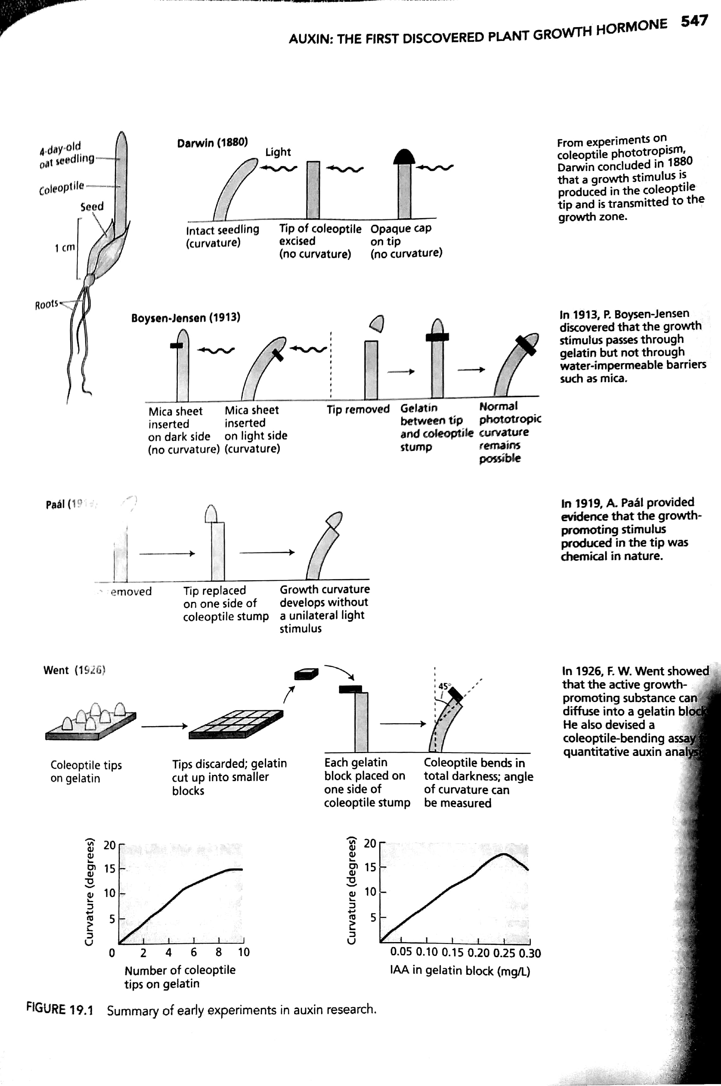
Chemical Nature of Auxin
Indole acetic acid (IAA) was the first Auxin to be isolated and studied. Later many auxins were discovered from plants but IAA is the most abundant. Now there are synthetic Auxins synthesized in laboratory, some of which are widely used in horticulture and agriculture.
Auxina are defined as compounds with biological activities similar to those of IAA, ability to promote elongation in coleoptile and cut stems, cell division in callus culture in presence of cytokinin, formation of adventitious roots on detached leaves and roots.
Example of natural and synthetic auxin given in the figure below
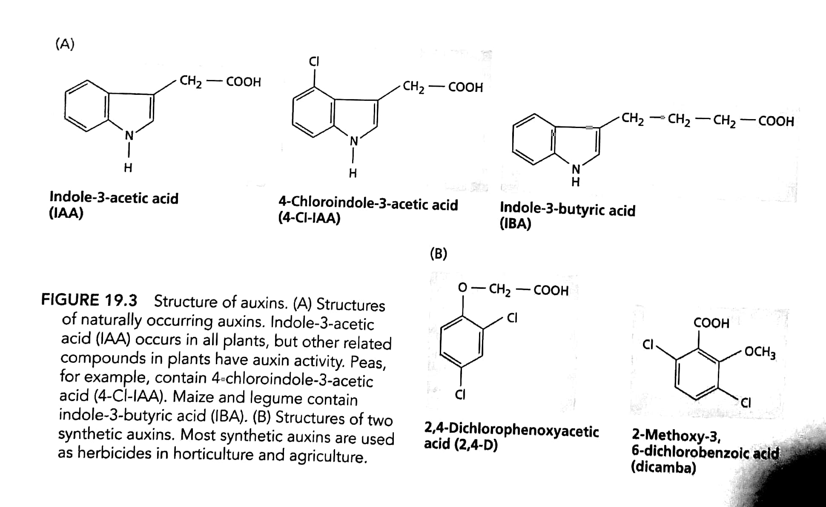
Auxin is synthesized in young dividing tissues and in meristems eg apical meristem, young leaves, root and shoot apex.
Pathway of Auxin synthesis
There are several pathways for IAA synthesis. IAA is similar in structure to amino acid Tryptophan and studies have shown that Trp is the precursor molecule for IAA synthesis.
- The IPA pathway- Most common; It involves a deamination (loss of amine) reaction to form IPA, followed by a decarboxylation reaction to form indole-3-acetaldehyde (IAld). Indole-3- acetaldehyde is then oxidized to IAA by a specific dehydrogenase.
- The TAM pathway-The tryptamine (TAM) pathway is similar to the IPA pathway, except that the order of the deamination and decarboxylation reactions is reversed, and different enzymes are involved.
- The IAN pathway- In the indole-3-acetonitrile (IAN) pathway tryptophan is first converted
to indole-3-acetaldoxime and then to indole-3-acetonitrile. This pathway occurs in Brassicacea, Musaceae and Poaceae.
- IAM pathway is used by bacteria e.g. Agrobacterium tumefaciens, Psuedomonas savastanoi.
IAA occurs in plant as conjugates with carbohydrates and amino acid form which is the inactive form. Free auxin is the biologically active form.
Low-molecular-weight conjugated auxins include esters of IAA with glucose or myo-inositol and amide conjugates such as IAA-N-aspartate. High-molecular-weight IAA conjugates include IAAglucan (7–50 glucose units per IAA) and IAA-glycoproteins found in cereal seeds.

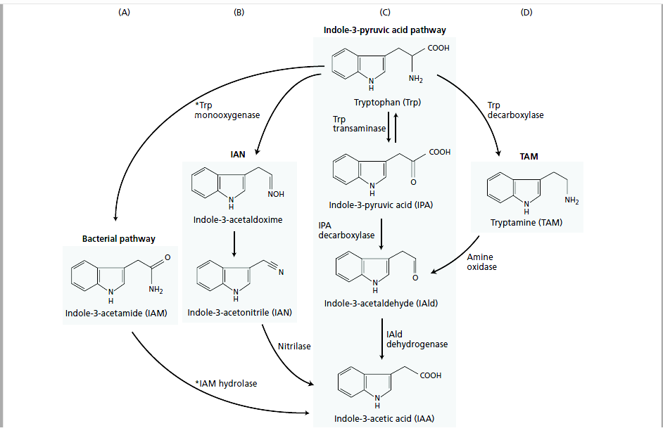

AUXIN TRANSPORT

IAA is distributed in Cytosol and Symplast and its distribution is regulated by pH. Auxin transport is
- Unidirectional or polar-It is Basipetal i.e. shoot apex serves as the primary source of auxin and it is transported towards base thus forming a gradient of Auxin extending from shoot tip to root tip. In root tip Auxin is also transported via phloem and this type of transport is called Acropetal (towards Apex).
- Polar Transport Requires Energy in form of ATP and Is Gravity Independent

To explain the polar transport of AUXIN Chemiosmotic hypothesis has been given.

Salient features of chemiosmotic model
- Polar transport of Auxin proceeds in a cell-to-cell fashion, rather than via the symplast.
- Auxin exits the cell through the plasma membrane, diffuses across the compound middle lamella, and enters the cell below through its plasma membrane.
- The loss of auxin from cells is termed auxin efflux; the entry of auxin into cells is called auxin uptake or influx.
- The overall process requires metabolic energy, as evidenced by the sensitivity of polar transport to O₂ deprivation and metabolic inhibitors.
- According to the model, auxin can enter plant cells from any direction by either of two mechanisms: 1. Passive diffusion of the protonated (IAAH) form across the phospholipid bilayer because IAAH is lipophilic or lipid loving thus easily transported across PM 2. Secondary active transport of the dissociated (IAA–) form via a 2H⁺–IAA– symporter (Proton pump). Here IAA^{–is} negatively charged and it needs transporter protein for influx as well as efflux.
- There occurs a pH gradient asross the plasma membrane and Apoplast. pH of cytosol is 7 where as that of cell wall or apoplast is 5. pH gradient is maintained by H⁺ATPase.
- Auxin enters the cytosol as IAAH, dissociates inside into IAA– and H⁺ . Auxin escapes from the cell via auxin efflux carrier protein, e.g. PIN protein is efflux carrier protein for Auxin in Arabidopsis thaliana.
Auxin inhibtors block Auxin transport by preventing Auxin efflux.

PHYSIOLOGICAL EFFECTS OF AUXIN

(Refer Taiz and Zyger for detail descriptions)
- Cell elongation- Auxins Promote Growth in Stems and Coleoptiles
- Tropic responses in plants is mediated by Auxin
- Auxin regulates apical dominance
- Auxin promotes lateral roots and adventitious root formation
- Auxin delays onset of leaf abscission
- Regulates floral bud development
- Induces Vascular differentiation- In undifferentiated cell or callus culture high auxin concentration leads to formation of both xylem and phloem where as only phloem is formed at low auxin concentration.
- Auxin regulates floral bud development
- Auxin promotes fruit developmemt

Commercial Application
- Used in horticulture widely for preventing fruit and leaf drop
- promotion of flowering in pineapple,
- induction of parthenocarpy
- As rooting hormone to induce rooting in stem cutting
- As herbicide- 2,4-D and DICAMBA are used as herbicide for broad leaved weeds, monocot crops rapidly inactivate these auxins by conjugation.
- Prevents sprouting of potatoes

Mode of Action
One of the physiological response of auxin on plant is cell elongation and expansion. It was suggested that auxin induces proton expulsion in cell wall causing acidification thus increasing cell extension.
Two hypothesis or possible mechanisms have been based
- Activation of preexisting plasma membrane H+-ATPases (Activation Hypothesis)- When auxin is the present in the surrounding, it bind to Auxin binding proteins which are receptors present on the plasma membrane. This induces a signal transduction to activate membrane bound H⁺ ATPase to extrude H ion or ABP directly activates H⁺ ATPase.

- Synthesis of new H⁺-ATPases on the plasma membrane (Synthesis Hypothesis)- The ability of protein synthesis inhibitors, such as cycloheximide, to rapidly inhibit auxin induced proton extrusion and growth suggests that auxin might also stimulate proton pumping by increasing the synthesis of the H⁺-ATPase.
Model for H⁺ extrusion and acidification of cell wall

SIGNAL TRANSDUCTION PATHWAY OF AUXIN

Receptor Protein- Auxin Binding protein ABP1 acts as receptors protein in the signal transduction pathway.

Second Messenger- Calcium and intercellular pH act a second messenger or intermediates in signal transduction pathway.

Expression of Auxin induced genes
Once ABP receptor protein binds to Auxin it induces signal transduction which ultimately leads to activation of Auxin related transcription factors which enters nucleus and promotes specific genes.
Auxin induced genes are classified into two types
Early induced genes- Those genes which are activated by stimulation of already present transcription factors in a cell are called primary response gene or early genes. Since all proteins are already present in the cell, expression of these genes are not inhibited by protein synthesis inhibitors such as cycloheximide. Thus these genes are expressed within short time…few seconds.
Function of early inducible genes
- Encode proteins that are transcription factors of late responsive genes.
- Genes involved in intercellular signaling
- Genes involved in adaptation to stress response
Few examples are The AUX/IAA gene family- Code for transcription factors for expression of late inducible genes;
SAUR gene family- Genes encoding proteins related to tropism
Late genes or secondary response gene- Those genes whose proteins are required for long term response of Auxin come under the category of late genes.

Reference
Taiz and Zeiger () Plant Physiology, Sinauer Associates Inc. Publishers, Massachusettes

